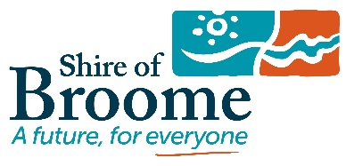
Shire of Broome Home Composting & Dual Bin Rebate
Application Form
To complete you application for a Home Composting & Dual Bin Rebate, please fill out this form and return it in person, post or email to:
Shire of Broome
27 Weld Street Broome / PO Box 44, Broome WA 6725 / Shire@broome.wa.gov.au

Full name:
Phone/Mobile:
Email:
Property address:
Nominated bank Account:
BSB:
Account number:
Product details:
Total amount spent on home composting products (inc GST):
Declaration (tick box)
- Be a shire resident.
- I have attached a recent bill showing my address in the Shire of Broome
- I have attached the receipt (less than 6 months old) for my purchase.
- I have not previously received a rebate for the Home composting & dual bin rebate.
- I have read and understood the terms and conditions of the rebate.
- Agree to be involved in future surveys to assist with determining the rebates effectiveness.
Signature of applicant:
Date:

