Community Sponsorship Program 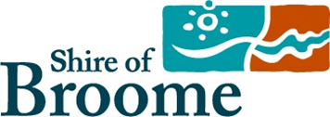
Acquittal Report - Financial Summary

The acquittal for your sponsorship must relate directly to the budget that formed your submission. Please complete the Financial Summary below and attach copies of invoices / receipts as well as any additional information or separate financial statements that may be useful as part of your online application.
Any unused sponsorship funds must be returned with this Acquittal Report.

Financial Summary

PROJECT INCOME | CASH ($)
Shire of Broome Community Sponsorship Program | $5170 (gst inc)
Other Funding - Please Specify | $1000 (BIA)
Merchandise sales, raffles and door collection | $1894
A Total Project Income | ($)8064
PROJECTEXPENDITURE | CASH ($) | Sponsorship Funding ($)
Prizes | $1511
Entertainment (Photographer, DJ, Welcome to country, kids entertainment) | 1945
Cleaning | $827
Furniture and signs | $473
Merchandise | $695
Website, containers hire venue | 1001
B Total Project Expenditure | ($)6452
C Budget Surplus / Deficit | ($) 1612
(A) Total Project Income - (B) Total Project Expenditure = (C) Project Surplus / Deficit

