Community Sponsorship Program 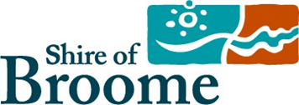
Acquittal Report - Financial Summary

The acquittal for your sponsorship must relate directly to the budget that formed your submission. Please complete the Financial Summary below and attach copies of invoices / receipts as well as any additional information or separate financial statements that may be useful as part of your online application.
Any unused sponsorship funds must be returned with this Acquittal Report.

Financial Summary

PROJECT INCOME | CASH ($)
Shire of Broome Community Sponsorship Program
Other Funding - Please Specify
A Total Project Income | ($)
PROJECTEXPENDITURE | CASH ($) | Sponsorship Funding ($)
B Total Project Expenditure | ($)
C Budget Surplus / Deficit | ($) 0.00
(A) Total Project Income - (B) Total Project Expenditure = (C) Project Surplus / Deficit

