|  |  |
| --- | --- |
| **Expression of Interest (EOI):** | *Lease of the Old Broome Lock Up*  *22 Carnarvon Street* |
|  |  |
| **Deadline:** | ***4:00PM WST 25 FEBRAURY 2022*** |
|  |  |
| **Address for Delivery:** | *Electronic Delivery ONLY to* [shire@broome.wa.gov.au](mailto:shire@broome.wa.gov.au) |

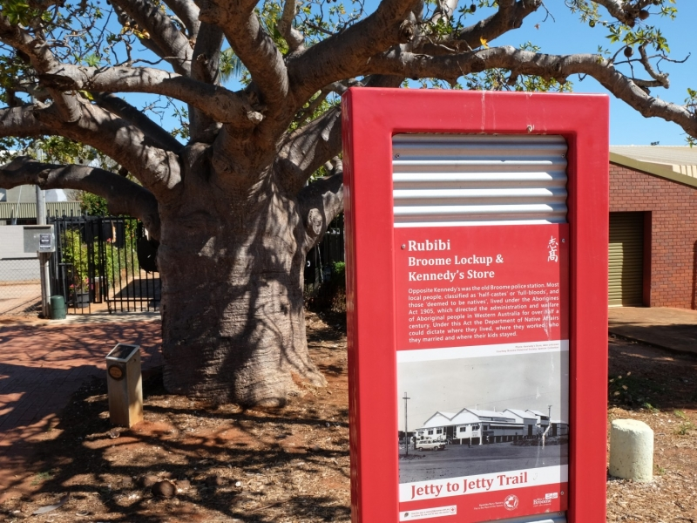

1 Conditions of Responding 4

1.1 Definitions 4

1.2 Expression of Interest Documents 4

1.3 How to Prepare Your Submission 4

1.4 Contact Persons 5

1.5 Briefing/Site Inspection 5

1.6 Evaluation Process 5

1.7 Statutory Processes Required to Dispose of Land 5

1.8 Selection Criteria 6

1.9 Compliance Criteria 6

1.10 Qualitative Assessment Criteria 6

1.11 Lodgement of Submissions and Delivery Method 7

1.12 Rejection of Submissions 7

1.13 Late Submissions 7

1.14 Disclosure of Contract Information and Documents 7

1.15 Respondents to Inform Themselves 7

1.16 Alterations 7

1.17 Ownership of Submissions 8

1.18 Canvassing of Officials 8

1.19 Costs 8

1.20 Conflict of Interest 8

1.21 Responsibility for Information 8

1.22 Absence of Obligations 9

1.23 No Lease 9

1.24 Disclaimer 9

2 Specification 10

2.1 Introduction The Old Broome Lock Up 10

2.2 Background Information 10

2.3 Long Term Lease 10

2.4 Site Description 11

2.5 Land Tenure 11

2.6 Key Lease Terms 13

2.7 Estimate Outgoings Issued by Shire of Broome 14

2.8 Relevant Supporting Documents 14

2.9 Indicative Floor Plan 14

3 Respondent’s Submission 16

3.1 Response Form 16

3.2 Selection Criteria 17

3.2.1 Compliance Criteria 17

3.2.2 Assessment Criteria 19

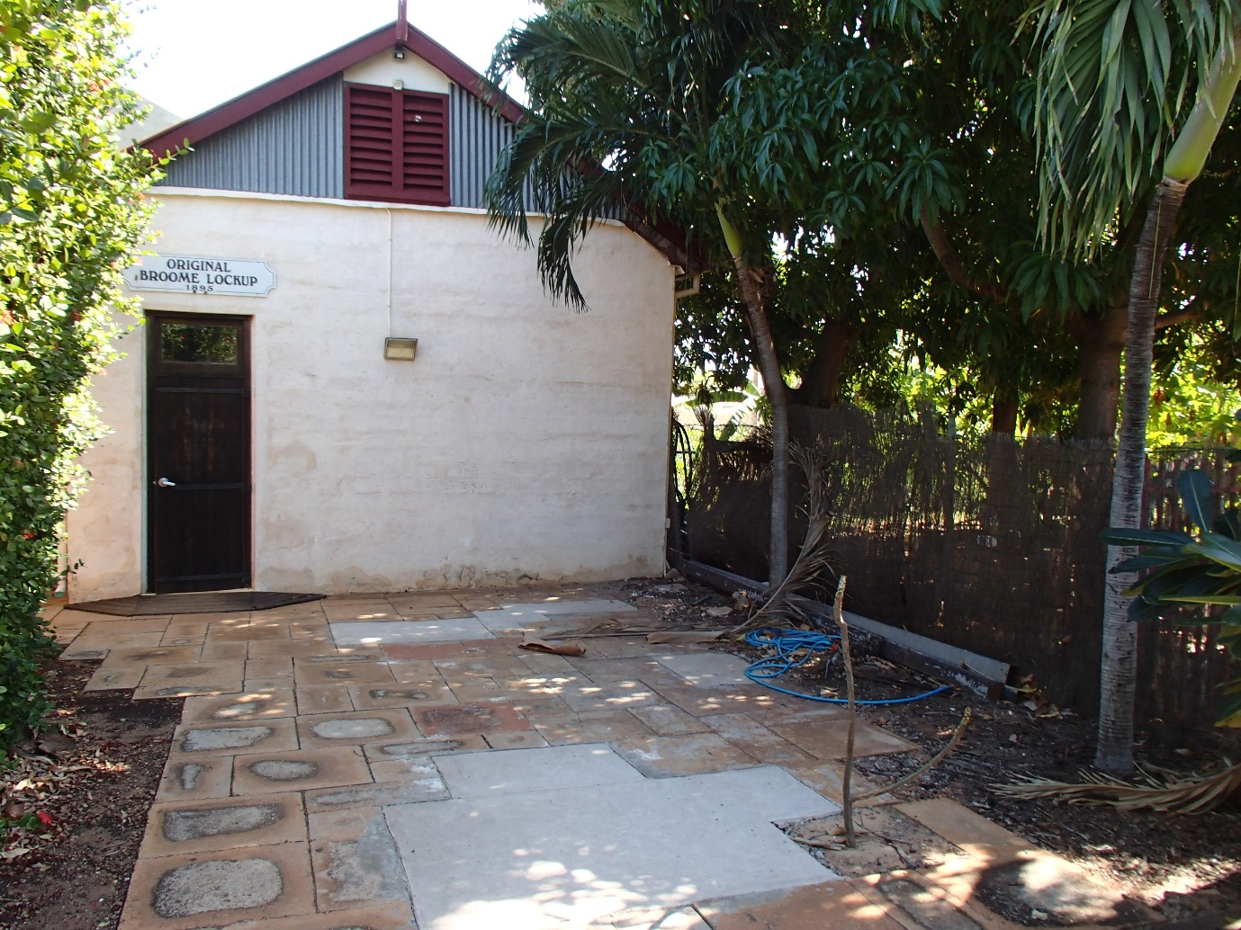

# Conditions of Responding

## Definitions

Below is a summary of some of the important defined terms used in this Expression of Interest:

|  |  |
| --- | --- |
| **Attachments:** | The documents you attach as part of your Submission. |
| **Deadline:** | The Deadline shown on the front cover of this Expression of Interest for lodgement of your Submission. |
| **Expression of Interest or EOI:** | This document. |
| **Principal:** | Shire of Broome |
| **Respondent:** | The person or persons, corporation or corporations who intends to submit a Submission in response to an Expression of Interest. |
| **Requirement:** | The Principal requires a suitable organisation to undertake the lease of the Old Broome Lock Up |
| **Selection Criteria:** | The Criteria used by the Principal in evaluating your Submission. |
| **Specification:** | The Statement of Requirements for the Lease of the Old Broome Lock Up that the Principal’s Expression of Interest may request you to provide if selected as an acceptable Expression of Interest through the Expression of Interest process. |
| **Submission:** | Completed Expression of Interest, response to Selection Criteria and Attachments. |

## Expression of Interest Documents

This Expression of Interest is comprised of the following parts:

Part 1 – Conditions of Responding *(read and keep this part)*.

Part 2 – Specification *(read and keep this part).*

Part 3 – Respondent’s Submission *(complete and return this part)*.

## How to Prepare Your Submission

1. Carefully read all parts of this document;
2. Ensure you understand the Requirements (Part 2);
3. Complete and sign the Response Form and your response to the Selection Criteria (Part 3) and attach your Attachments; and
4. Lodge your Submission before the Deadline.

## Contact Persons

Respondents must not rely on any information provided by any person other than the person listed below:

|  |  |
| --- | --- |
| **Name:** | Senior Property and Leasing Officer – Kristin Martin |
| **Telephone:** | *08 9191 3421* |
| **Email:** | [property@broome.wa.gov.au](mailto:property@broome.wa.gov.au) |

## Briefing/Site Inspection

Attendance at this meeting not mandatory.

Respondents are welcome to attend a Site Inspection with Kristin Martin at the Site.

## Evaluation Process

This is an Expression of Interest (EOI).

Following the close of the EOI, Submissions will be evaluated and an evaluation report will be prepared for approval of the Shire of Broome Council. Following approval by Council, the Principal will commence direct negotiations of the lease with the preferred Respondent at the Principal’s sole discretion.

Your Submission will be evaluated using information provided in your EOI and on your response to the Selection Criteria.

The following Evaluation Methodology will be used in respect of this Expression of Interest:

1. Submissions are checked for completeness and compliance. Submission that do not contain all information requested (eg competed Submission Form and Attachments) may be excluded from evaluation;
2. Submissions will be assessed against the Compliance and eligibility Criteria prior to the Qualitive Assessment Criteria
3. Submissions are then assessed against the Qualitive Assessment Criteria.

## Statutory Processes Required to Dispose of Land

The successful leasing opportunity will be required to meet statutory requirements of the Local Government Act 1995 (the Act). Pursuant to section 3.58 of the Act, subject to some exceptions the Shire of Broome can sell or lease its land only –

a) To the highest bidder at public auction

b) To the person who at public auction called by the Shire, makes what is, in the opinion of the Shire, the most acceptable tender, whether or not it is the highest tender; or

c) By giving local public notice of the details of the proposed disposition and complying with the requirements of section 3.58 (3) and (4) and of the Local Government Act.

The Shire of Broome will advertise its intentions to dispose of its interest in the land (Old Broome Lock Up) by leasehold tenure by giving public notice of the proposed disposition, including an invitation for public submissions.

## Selection Criteria

A scoring system of 1 to 10 will be used as part of the assessment of the qualitative criteria set out in Part 3. Unless otherwise stated, a response to one of these criteria which provides all the information requested in the Expression of Interest will be assessed as satisfactory and will, in the first instance, attract an average score.

The extent to which the Submission demonstrates greater or lesser satisfaction of each of these criteria will result in a score greater or lesser than the average. The aggregate score of each Submission will be used as one of the factors in the final assessment of the qualitative criteria and in the overall assessment of value for money.

## Compliance Criteria

These criteria are detailed within Part 3 of this document and will not be point scored. Each Submission will be assessed on a “Yes/No” basis as to whether the criterion is satisfactorily met. An assessment of “No” against any criterion may eliminate the Submission from consideration.

## Qualitative Assessment Criteria

In determining the most advantageous Submission, the Evaluation Panel will score each Respondent against the qualitative criteria as detailed within Part 3 of this document. Each criterion will be weighted to indicate the relative degree of importance that the Principal places on the technical aspects of the goods or services being purchased.

Note: It is essential that Respondents address each qualitative criterion.

Information that you provide addressing each qualitative criterion will be point scored by the Evaluation Panel.

Failure to provide the specified information may result in elimination from the evaluation process or a low score.

## Lodgement of Submissions and Delivery Method

The Submission must be lodged by the Deadline. The deadline for this Expression of Interest is **4.00pm WST on 25 February 2022.**

The Submission is to be submitted by electronic mail. Submissions will be accepted at **shire@broome.wa.gov.au**

Submissions submitted by **post, facsimile or hand delivered** **will not** be accepted.

## Rejection of Submissions

A Submission will be rejected without consideration of its merits in the event that:

1. it is not submitted before the Deadline; or
2. it may be rejected if it fails to comply with any other requirements of the Expression of Interest.

## Late Submissions

A Submission received after the Deadline will not be accepted for evaluation.

## Disclosure of Contract Information and Documents

Documents and other information relevant to the contract may be disclosed when required by law under the Freedom of Information Act 1992 or under a Court Order.

## Respondents to Inform Themselves

Respondents shall be deemed to have:

1. examined the Expression of Interest and any other information available in writing to Respondents for the purpose of submitting an EOI;
2. examined all further information relevant to the risks, contingencies and other circumstances having an effect on their Submission which is obtainable by the making of reasonable enquiries;
3. satisfied themselves as to the correctness and sufficiency of their Submissions including submitted indicative prices which shall be deemed to cover the cost of complying with all the conditions of responding and of all matters and things necessary for the due and proper performance and completion of the work described therein; and
4. satisfied themselves they have a full set of the EOI documents and all relevant attachments.

## Alterations

The Respondent shall not alter or add to the Expression of Interest documents unless required by these General Conditions of Responding.

The Principal will issue an addendum to all registered Respondents where matters of significance make it necessary to amend the issued Expression of Interest documents before the Deadline.

## Ownership of Submissions

All documents, materials, articles and information submitted by the Respondent as part of or in support of a Submission shall become upon submission the absolute property of the Principal and will not be returned to the Respondent at the conclusion of the Submission Process PROVIDED that the Respondent shall be entitled to retain copyright and other intellectual property rights therein, unless otherwise provided by the Contract.

## Canvassing of Officials

If a Respondent, whether personally or by agent, canvasses any of the Principal’s Commissioners or Councillors (as the case may be) or Officers with a view to influencing the acceptance of any Respondent, then regardless of such canvassing having any influence on the acceptance of such Submission, the Principal may at its discretion omit the Respondent from consideration.

## Costs

Costs and expenses incurred by Respondents in any way associated with the preparation and submission of their EOI, will be entirely borne by the Respondent.

## Conflict of Interest

Respondents and their respective officers, employees, agents and advisors must not place themselves in a position that may, or does give rise to a conflict of interest (or potential conflict of interest) between the interests of the Principal (on the one hand) and other interests (on the other hand) during the EOI process.

## Responsibility for Information

All the information that the Principal provides to a Respondent, whether in documents or not, is provided in good faith to assist Respondents. None of the information is guaranteed. It is the Respondent’s responsibility to interpret and assess the relevance of the information provided. The Principal is not liable for any loss, damage or expense suffered by a Respondent as a result of any inaccuracy in the information provided.

## Absence of Obligations

No legal or other obligation will arise between a proponent and the Principal unless or until formal documentation has been signed. In this regard the Principal is not obliged to proceed with any EOI submissions in whole or in part.

## No Lease

This document does not constitute an offer to lease.

If the Principal enters into negotiations with the Respondent, the Respondent must negotiate in good faith with the Principal to agree and finalise the Lease, which will be based on the Key Lease terms and any other terms required by the Principal.

If the Principal enters into negotiations with the Respondent, this does not constitute an acceptance of the submission received by the Respondent or otherwise confer any rights on a Respondent and is without prejudice to the right of the Principal to decline to enter into the final Lease, or to enter into the final Lease with the Respondent or a competing Respondent.

The Principal may choose to negotiate any aspect of a submission.

## Disclaimer

Respondents must rely on their own investigations and should satisfy themselves in relation to all aspects of their proposal and the information set out in this document or any document attached or related to it. The lessor and its respective employees, officer, consultants and professional advisors are not liable for any incorrect, incomplete or misleading information or failure to disclose information, whether in connection with this document or any document attached or related to it. This document or any document attached or related to it may be subject to review or change at any time without notice.

# Specification

## Introduction The Old Broome Lock Up

The Shire of Broome is offering for lease The Old Broome Lock Up located at 22 Carnarvon Street. Expressions of Interest are being sought from local organisations of all natures, who will bring a unique business to the premise, encouraging activation of the extended Chinatown precinct.

The building was constructed in 1986 in association with the original Broome Police Station which stood on the corner of Napier Terrace and Carnarvon Street. While other buildings were demolished, The Old Broome Lock Up has remained. The building makes a part of the ‘Jetty to Jetty’ heritage walking trail from Streeters Jetty along the coast line to ‘Old Jetty’ at Town Beach. The site is was previously operated as an office space and restaurant, with improvements made to the two toilets in the rear courtyard.

## Background Information

The ‘Old Broome Lock Up’ was constructed in 1986 in association with the original Broome Police Station, which stood on the corner of Napier Terrace and Carnarvon Street where ‘Wings’ restaurant now stands. The ‘Old Broome Lock Up’ and former ‘Customs House’ building were located on the same parent Lot 19. Following the relocation of the Broome Police Station to it’s current location in 1965, and the demolition of the former ‘Customs House’ in the late 1960’s, the ‘Old Broome Lock Up’ building remained and was utilised for a range of purposes, some of which being a ‘Blacksmith Tourist Attraction’, Multiple forms of Art Galleries, a Coffee House, a Cultural Tourism hub and most recently, the cells were used as office space by RFF Pty Ltd who utilised the front courtyard as food and beverage business.

## Long Term Lease

The lease is intended for an initial term of up to five years. If the successful applicant intends to operate a retail or hospitality business at 22 Carnarvon, the lease will fall under the *Commercial Tenancy (Retail Shops) Agreements Act 1985 (‘the Act’).* Ordinarily, the minimum term prescribed under the Act is 5 years unless a shorter term is agreed by the parties and approved by the State Administrative Tribunal*.* Any prospective tenant will need to acknowledge that they accept the reduced term at their own free will, and that they will agree to make an application to the State Administrative Tribunal to approve the reduced term of the lease.

A market valuation was conducted of the Premises building on 2 February 2022 which determined a fair and reasonable commencement rent of $17,500 plus GST per annum, excluding standard property outgoings.

## Site Description

The 318sqm site is located within the ‘Town Centre’ zone and is positioned on the Western side of Carnarvon Street and falls within the Chinatown Development Strategy (CDS) area. With approximate 6m frontage to Carnarvon Street, the lot is accessible to foot traffic only with no delineated on-site car parking available.

Adjoining development consists of an ‘Office’ land-use utilised by DFES to the south, Wing’s restaurant to the north, with a two-storey, multiple dwelling development adjoins to the west. Adjacent development across Carnarvon Street comprises a mixture of ‘Office’ tenancies and multiple dwelling residential developments. It is also noted than an existing residential use, (which formed part of the Planning Approval previously granted to Wing’s Restaurant on 6 June 2007), immediately abuts the portion of the site where the outdoor courtyard is situated.

The gross lettable area of the site is 318sqm which includes a heritage building containing three air-conditioned cells of approximately 8.5msq lettable area each, adjoined by a corridor, and a single toilet at the far end. An ablution block of approximately 11msq located in the rear courtyard, leaving approximately 233sqm of surrounding paved courtyard.

## Land Tenure

The Premises are situated on Freehold land, Lot 1 on diagram 90609, Number 22 Carnarvon Street. The site located on the Western side of Carnarvon Street within the ‘Town Centre’ zone. The site falls under the Chinatown Development Strategy area and features the State Heritage Listed ‘Old Broome Lock Up’ and ‘Boab Tree’ and is also classified on the National Trust List.

## Key Lease Terms

The following key terms will form part of the lease contract:

* Term of the lease will be up to 5 years initially
* Tenant to acknowledge that if the lease term is less than the minimum of 5 years in accordance with Commercial Tenancy (Retail Shops) Agreements Act 1985 and that they accept the reduced term at their own free will. The Tenant will be required to make an application with the Landlord to the State Administrative Tribunal to approve the reduced term of the lease.
* Commencement rent at market rent provided through Senior Property and Leasing Officer.
* Tenant to take property on an ‘as is’ basis
* Tenant Responsible for fit out
* Tenant Responsible for all operational maintenance and repair costs associated with the Premises
* Tenant Responsible for all outgoings to Premises
* CPI review upon the anniversary of the commencement date, and Market Review as stipulated in the lease terms

## Estimate Outgoings Issued by Shire of Broome

The following is an estimate of outgoings issued by the Shire of Broome (only).

* Water Consumption Charges 20/21 Financial Year $2,542.19
* Building Insurance 20/21 $2,025.39 (pro rata)
* Biannual Pest Inspection 20/21 $75.00
* Shire Rates & ESL 20/21 $1,773.16

## Relevant Supporting Documents

The following documents can be accessed on the Shire of Broome website:

* + 1. Broome Chinatown Masterplan Report <http://www.broome.wa.gov.au/files/assets/public/building/major-projects/broomechinatownmasterplanreport.pdf>
    2. Chinatown Public Art and Interpretation Strategy <http://www.broome.wa.gov.au/files/assets/public/building/major-projects/2018-05-28-chinatown-public-art-strategy-for-construction-rev-b.pdf>
    3. Chinatown Place Management Plan

<http://www.broome.wa.gov.au/files/assets/public/building/major-projects/chinatownplacemakingmanagementplan.pdf>

## Indicative Floor Plan

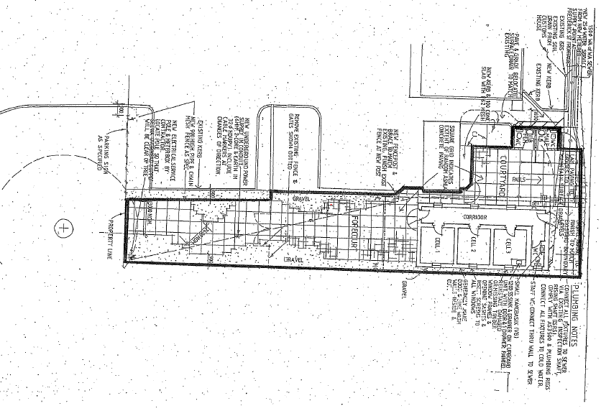

# Respondent’s Submission

## Response Form

The Chief Executive Officer

Shire of Broome

27 Weld Street, Broome WA 6725

I/We (Registered Entity Name):

(BLOCK LETTERS)

of:

(REGISTERED STREET ADDRESS)

ABN ACN (if any)

Telephone No: Facsimile No:

E-mail:

**In response to Expression of Interest (EOI) for*****Lease of The Old Broome Lock Up***

I/We agree that I am/We are bound by, and will comply with this Expression of Interest and its associated schedules, attachments, all in accordance with the Conditions contained in this EOI signed and completed.

I/We agree that there will be no cost payable by the Principal towards the preparation or submission of this Submission irrespective of its outcome.

I/We agree of my/our own free will that should my/our submission be successful and fall under the *Commercial Tenancy (Retail Shops) Agreements Act 1985* and the proposed lease term is less than the prescribed term under such Act, approval of the reduced term to the State Administrative Tribunal is required.

The consideration is as provided under the schedule of rates of prices in the prescribed format and submitted with this Submission.

Dated this day of 20

Signature of authorised signatory of Respondent:

Name of authorised signatory (BLOCK LETTERS):

Position:

Telephone Number:

Authorised signatory Postal address:

Email Address:

## Selection Criteria

The following sections contain the selection criteria has been developed to assess your submission to determine the suitability to be listed as an Acceptable Respondent. Where it is necessary to provide additional information, please ensure that all documents are clearly marked with the relevant attachment title to assist the evaluation panel with their assessment.

(Note: All pages within Part 3 are to be completed and returned to the Principal as they form part of your Submission).

### Compliance Criteria

Please select with a “Yes” or “No” whether you have complied with the following compliance criteria:

|  |  |
| --- | --- |
| **Description of Compliance Criteria** | **Please Circle** |
| 1. Does the Respondent comply with the Conditions of Responding contained in this Expression of Interest? | Yes / No |
| 1. Does the Respondent acknowledge, agree and comply with the Specification contained in this Expression of Interest. | Yes / No |
| 1. Business Structure   *Have you included in your response:*   1. *An outline of your organisational structure inclusive of any branches and number of personnel.* 2. *If companies are involved, attach their current ASIC company extracts search including latest annual return.* 3. *Provide the organisations directors/company owners and any other positions held with other organisations.* 4. *Provide a summary of the number of years your organisation has been in business.* 5. *Attach details of your referees. You should give examples of work provided for your referees where possible.* 6. *Are you acting as an agent for another party? If Yes, attach details (including name and address) of your principal.* 7. *Are you acting as a trustee of a trust? If Yes, give the name of the trust and include a copy of the trust deed (and any related documents); and if there is no trust deed, provide the names and addresses of beneficiaries.* 8. *Do you intend to subcontract any of the Requirements? If Yes provide details of the subcontractor(s) including; the name, address and the number of people employed; and the Requirements that will be subcontracted.* 9. *If you are intending on responding as a separate entity do you agree to provide a Personal Guarantee for the Lease* | Yes / No  Yes / No  Yes / No  Yes / No  Yes / No  Yes / No  Yes / No  Yes / No  Yes / No |
| 1. Financial Capacity 2. *Are you presently able to pay all your debts in full as and when they fall due?* 3. *Are you currently engaged in litigation as a result of which you may be liable for $50,000 or more? If Yes please provide details.* 4. *In order to demonstrate your financial ability to undertake this contract, include a profit and loss statement and the latest financial return for you and each of the other proposed contracting entities, together with a list of financial referees from your bank and/or accountant.* | Yes / No  Yes / No  Yes / No |
| 1. Insurance Requirements 2. *Respondents are to provide their insurance for the leasing requirements of this Contract for the following:*     1. *Public Liability ($20M) for any one occurrence, unlimited occurrences*    2. *Property, physical or accidental loss or damage for full value* 3. *If the Respondent does not currently meet the above minimum insurance requirements, does the Proponent agree to amend its insurance policies to meet these requirements at no additional cost to the Lessor prior to the award of the Lease?* | Yes / No  Yes / No  Yes / No |

### 

### Assessment Criteria

Before responding to the following qualitative criteria, Respondents must note the following:

1. All information relevant to your answers to each criterion are to be contained within your Submission;
2. Respondents are to assume that the Evaluation Panel has no previous knowledge of your organisation, its activities or experience;
3. Respondents are to provide full details for any claims, statements or examples used to address the qualitative criteria; and
4. Respondents are to address each issue outlined within a qualitative criterion.

|  |  |  |  |
| --- | --- | --- | --- |
| **Objective** | **Submission Requirements** | **Weighting** | **Tick If Attached** |
| **Reputable and Proven Operator** | Demonstrate at least five (5) years experience in managing, owning or operating a viable business | **25%** | **❑** |
| **Financial Capability & Resources** | Respondent should demonstrate the financial capability and resources to undertake the proposal and daily running of the business to ensure its sustainability and optimal opening hours, year round. | **25%** | **❑** |
| **Proposal that Complements China Town and showcases historical value** | Respondent must be able to demonstrate their vision or ideas for the Premises and how their vision will promote activation of the China Town area, and allow members of the public to enjoy the Heritage Listed site. | **50%** | **❑** |